OPERATING SYSTEMS AND SYSTEMS PROGRAMMING
(25CS2104E)

FINAL PROJECT REPORT

PROCESS TERMINATION MESSAGE SYSTEM

Section 08 | Team 10

TEAM MEMBERS
2520030432 – K ANUSRI
2520030440 – K ANSHU
2520030193 – K DHEERAJ
2520030028 – B MOHITH

1. ABSTRACT
The Process Termination Message System is a Linux-based C program designed to monitor and report the termination of child processes created by a parent process. The system demonstrates process creation, parent-child relationships, synchronization, normal and abnormal process termination, signal handling, and zombie prevention.
The enhanced implementation allows the user to select the number of child processes between 3 and 100. Each process is assigned a PID and monitored through states such as PENDING, STARTED, PROCESSING, TERMINATING, and TERMINATED. A menu-driven interface allows the user to query a process by PID, display all process statuses, send SIGKILL to a selected PID, and display the termination report.

2. PROBLEM STATEMENT
A fixed three-child implementation limits the demonstration of process management and makes it difficult to monitor a variable number of processes. The project extends the system so that the user can select the number of child processes and monitor their execution and termination using their actual PIDs.

3. OBJECTIVES
- Create a user-selected number of child processes from 3 to 100.
- Demonstrate process creation using fork().
- Track process PIDs and execution states.
- Provide PID-based status checking.
- Display all child processes in a status table.
- Demonstrate normal termination using exit().
- Demonstrate abnormal termination using SIGKILL.
- Detect termination using WIFEXITED(), WEXITSTATUS(), WIFSIGNALED(), and WTERMSIG().
- Use waitpid() to collect terminated children and prevent zombie processes.

4. METHODOLOGY
The parent process asks the user to select the number of child processes. Shared memory created using mmap() stores the PID, child number, state, exit status, and signal information for each child. The parent creates the requested children using fork().
Each child enters a processing phase and reports its progress. Child-3 is intentionally terminated by the parent using SIGKILL to demonstrate abnormal termination. The parent uses waitpid() with WNOHANG to collect terminated children without blocking the monitoring interface. The menu remains active until the user chooses option 5.

5. PROCESS STATES
State | Meaning
PENDING | Process entry initialized but not yet started.
STARTED | Child process has been created and started.
PROCESSING | Child is performing its assigned work.
TERMINATING | Process is completing or being terminated.
TERMINATED | Parent has collected the process termination status.

6. SYSTEM CALLS, FUNCTIONS AND MACROS
API / Macro | Purpose
fork() | Creates a child process.
getpid() | Obtains the process ID.
exit() | Terminates a child normally with an exit status.
wait() | Collects child process termination.
waitpid() | Collects terminated child processes.
WNOHANG | Allows waitpid() to return without blocking.
kill() | Sends a signal to a process.
SIGKILL | Forces abnormal process termination.
WIFEXITED() | Checks normal termination.
WEXITSTATUS() | Obtains normal exit status.
WIFSIGNALED() | Checks signal-based termination.
WTERMSIG() | Obtains the terminating signal.
mmap() | Creates shared memory for process information.
munmap() | Releases shared memory.

7. SOURCE CODE SCREENSHOTS
Take the following screenshots from the Ubuntu terminal/Nano editor and paste each screenshot in the indicated place.
Screenshot 1: Beginning of termination.c: headers, ProcessState and ProcessInfo.

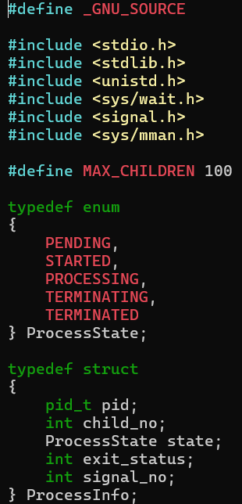

Screenshot 2: state_name(), find_index_by_pid(), and show_process().
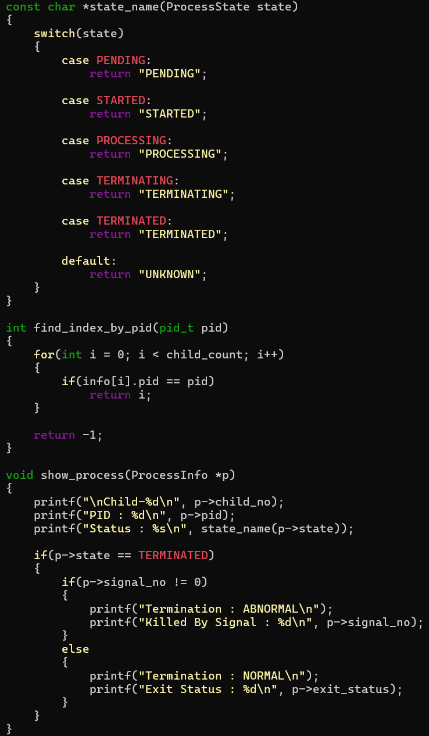

Screenshot 4: show_all() and terminate_child().
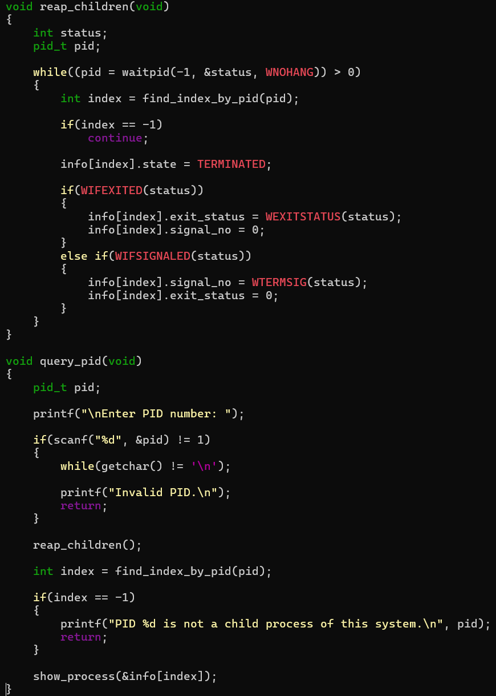

Screenshot 4: show_all() and terminate_child().
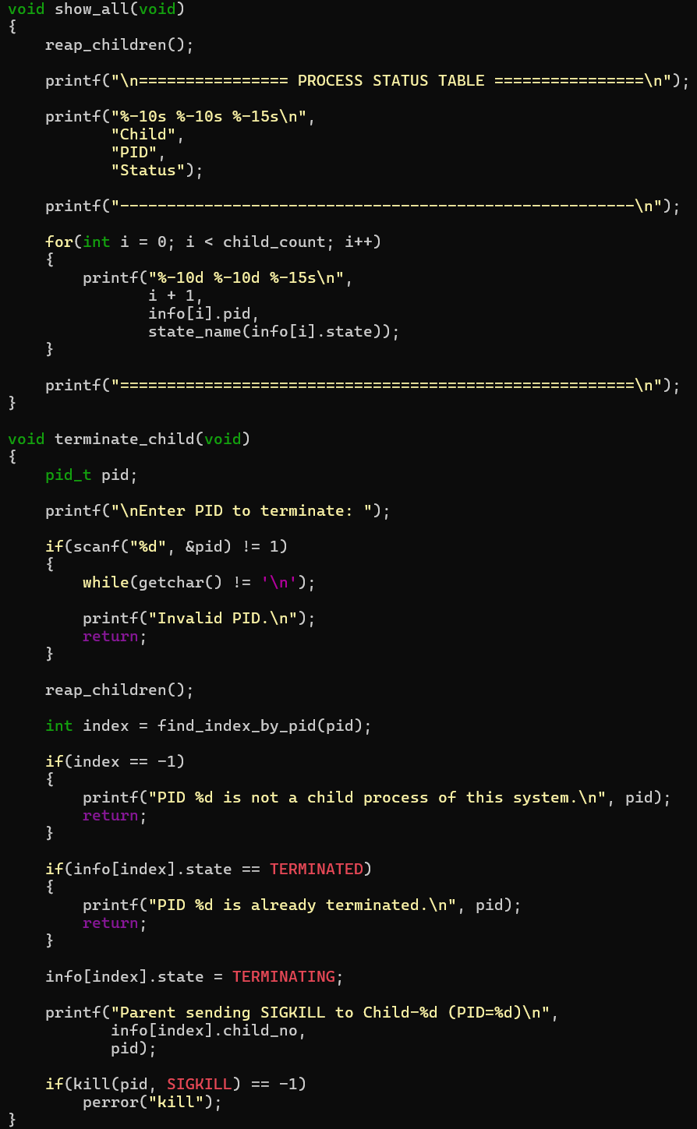

Screenshot 5: main(): user input for 3–100 processes and mmap initialization.
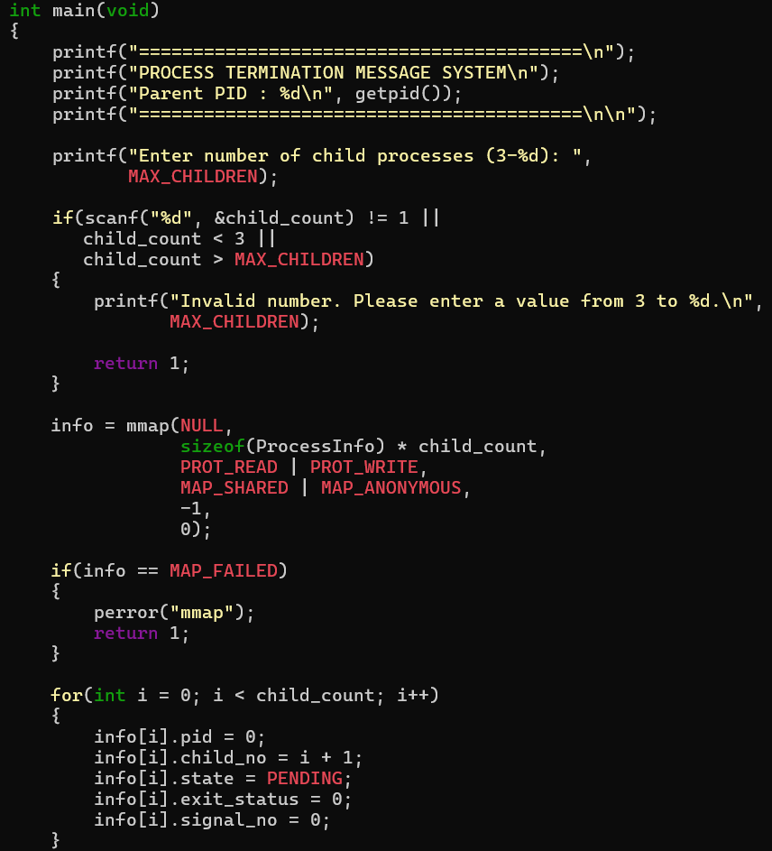

Screenshot 6: main(): fork loop, child processing, and termination logic.
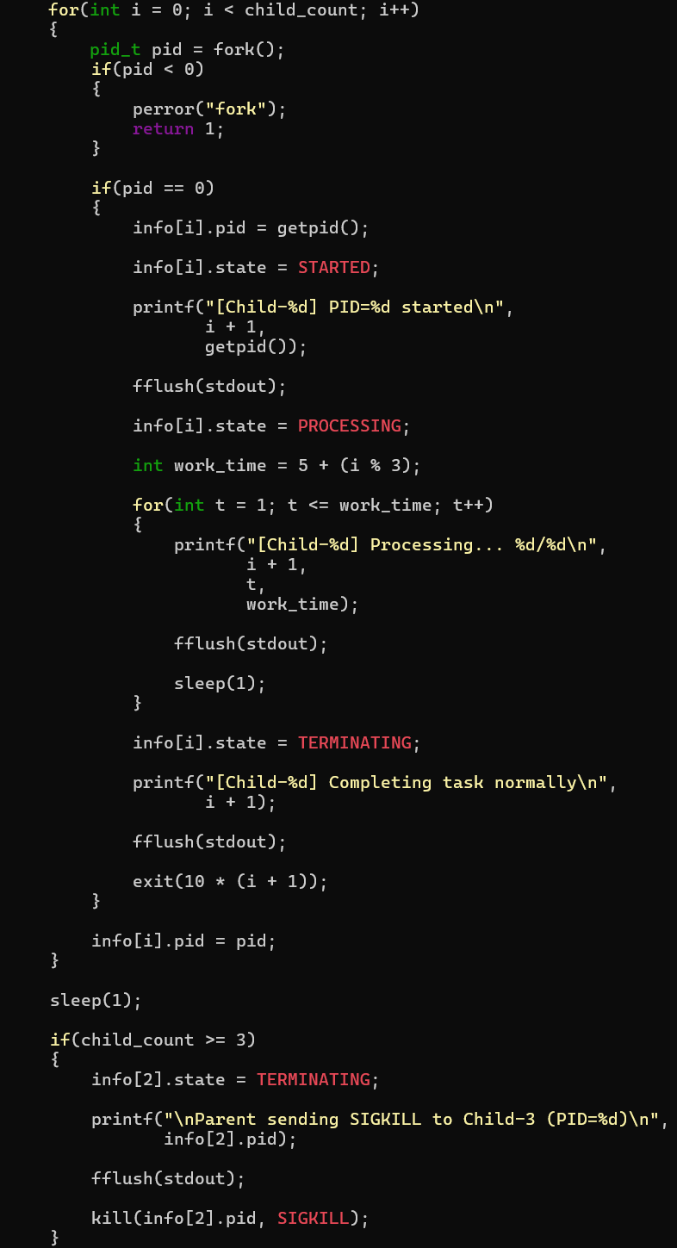

Screenshot 7 (Part 1 of 2): main(): interactive menu and choices 1–3.
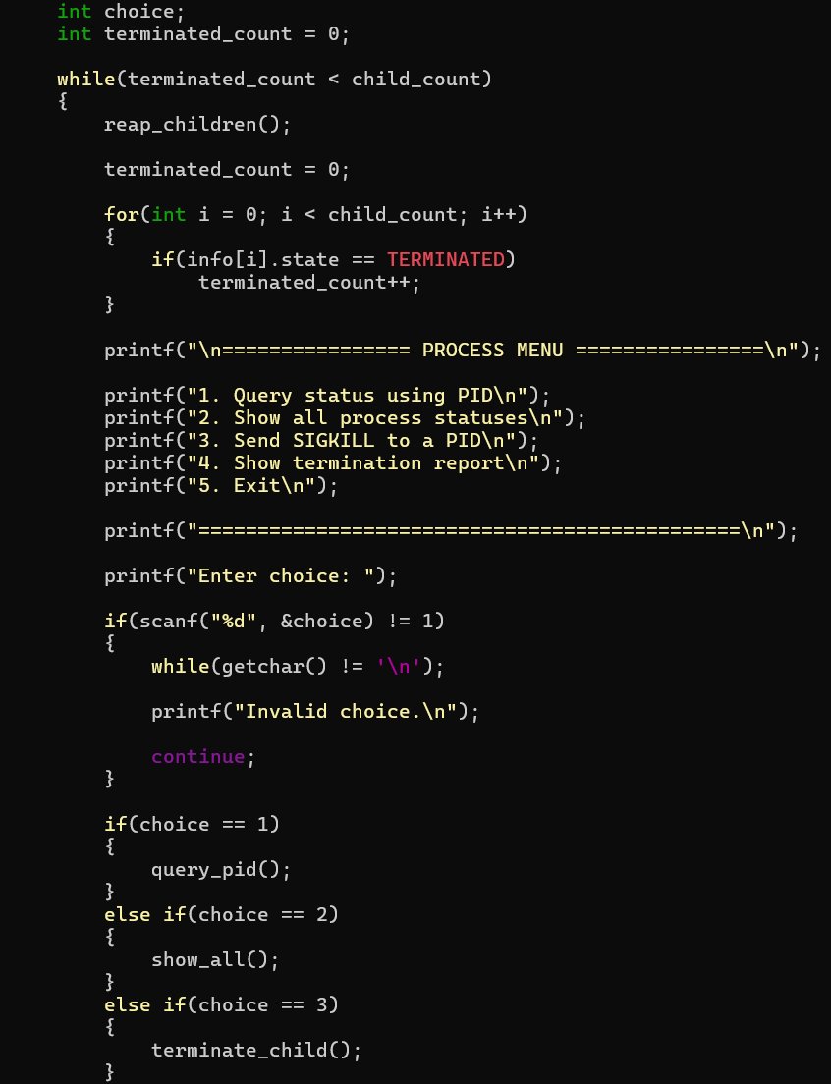

Screenshot 7 (Part 2 of 2): main(): termination report (choice 4).
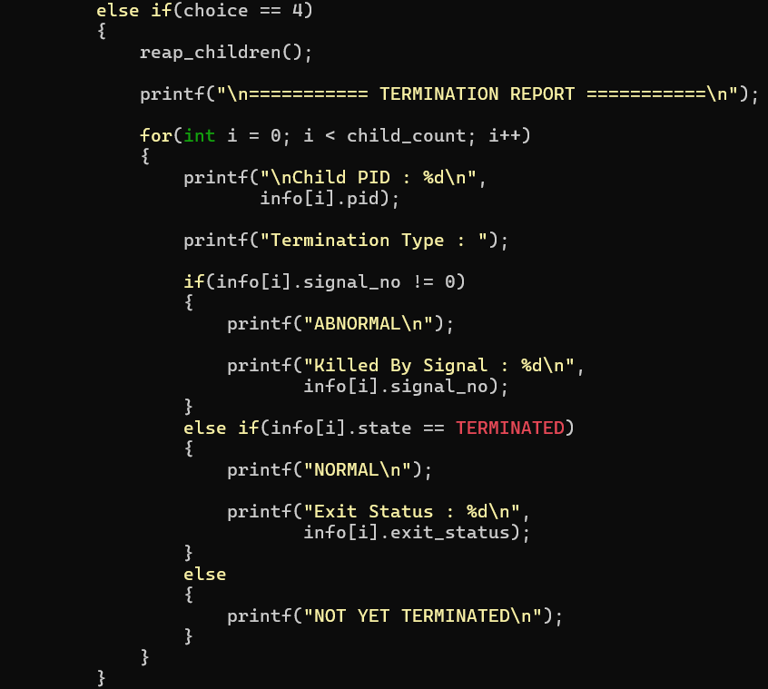
Screenshot 8: End of program: wait(), final messages, munmap(), and return.
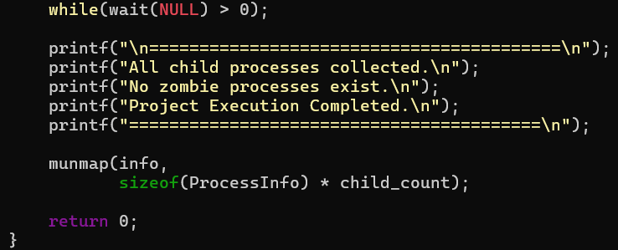

8. CREATING AND SAVING THE SOURCE FILE
Source file command:
nano termination.c
The file was saved using Ctrl+O, Enter, and Nano was exited using Ctrl+X.
Screenshot 9: termination.c open in Nano.
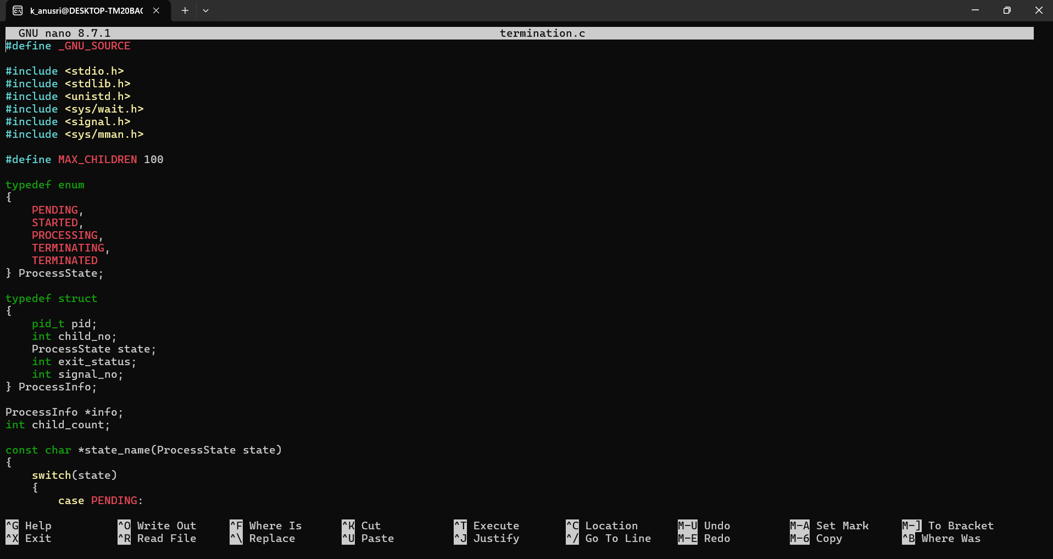

Screenshot 10: Saved source file / terminal after exiting Nano.
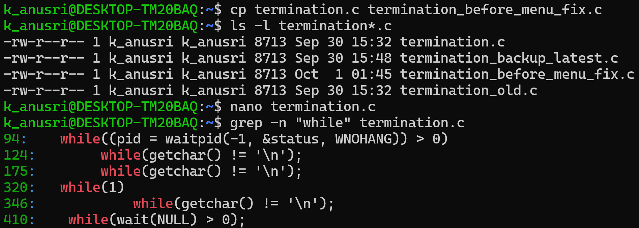

9. COMPILATION
Compilation command: gcc termination.c -o termination
Screenshot 11: Successful compilation with no error message.

10. PROGRAM EXECUTION
Execution command: ./termination
Demonstrated test: user selected 5 child processes.
Screenshot 12: Program start showing parent PID and input for number of child processes.
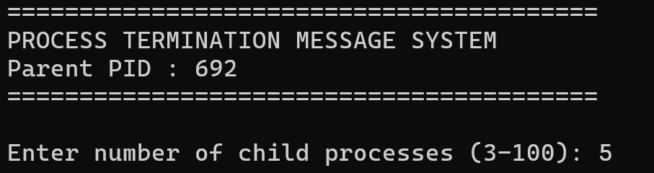

Screenshot 13: Five child processes starting, showing their PIDs and processing progress.
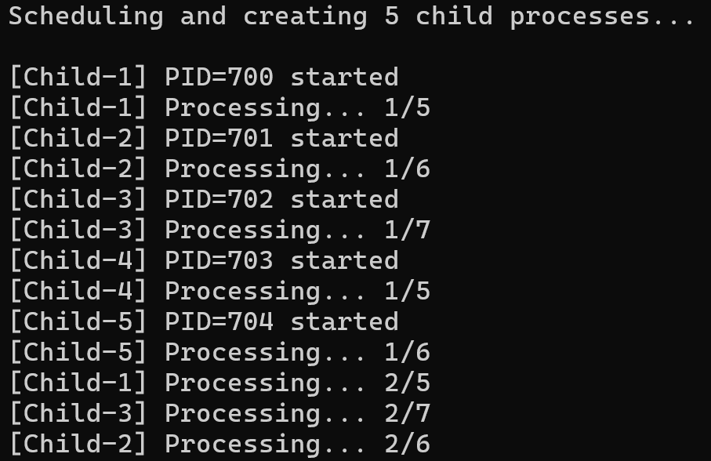

Screenshot 14: Parent sending SIGKILL to Child-3.

Screenshot 15: Interactive process menu.
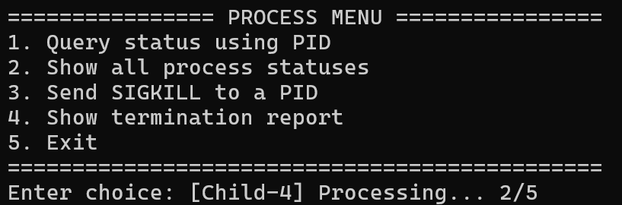

11. PROCESS STATUS TABLE
Option 2 displays all child processes and their status.
Screenshot 16: Option 2 — complete status table for all five children.
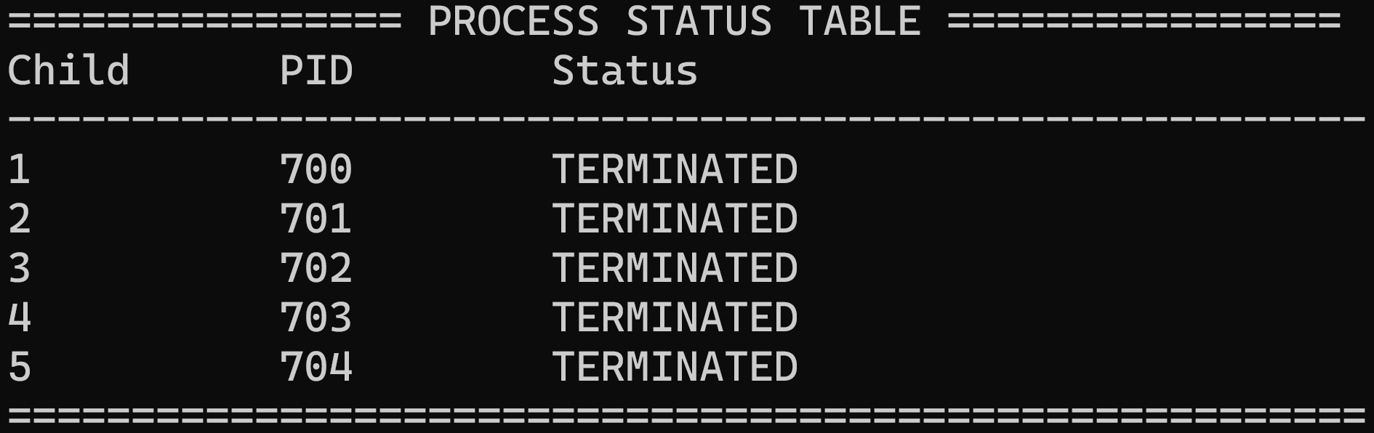

12. PID-BASED STATUS VERIFICATION
Option 1 allows the user to enter the actual PID from the current execution. Each PID was queried individually.
Screenshot 17: Query Child-1 using its actual PID — normal termination and exit status.
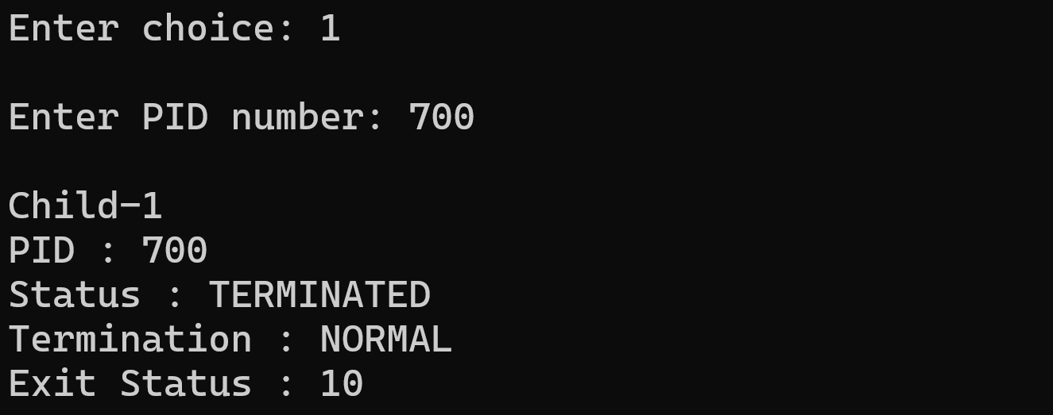

Screenshot 18: Query Child-2 using its actual PID — normal termination and exit status.
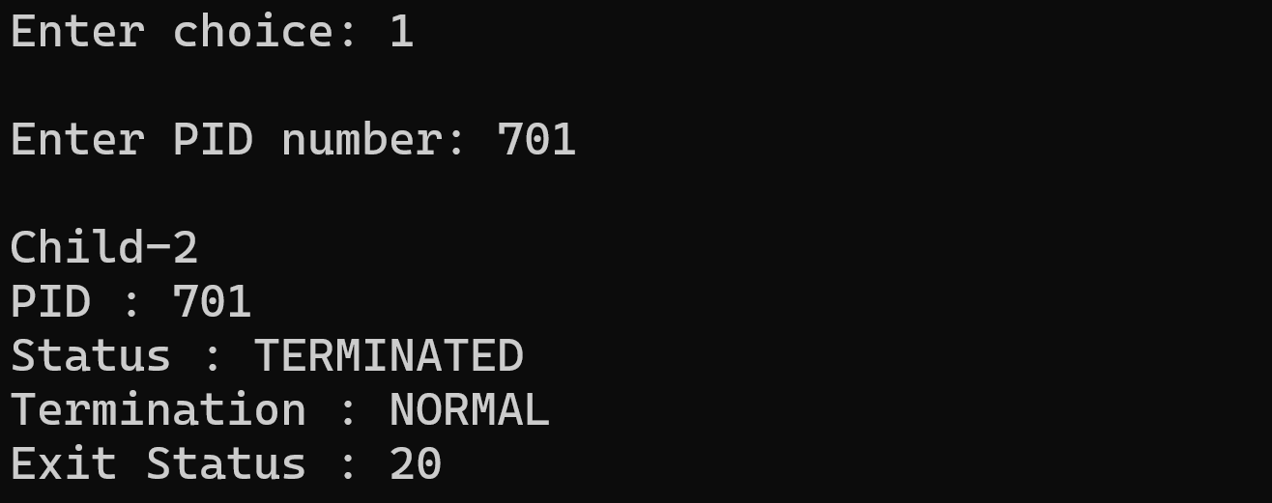
Screenshot 19: Query Child-3 using its actual PID — abnormal termination and signal 9.
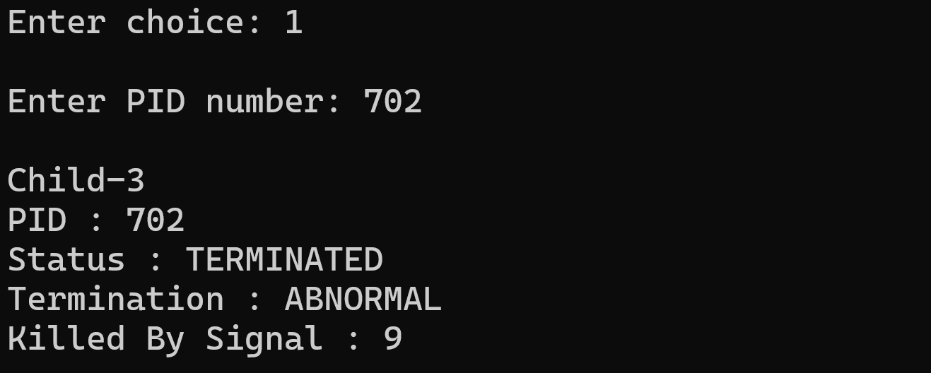
Screenshot 20: Query Child-4 using its actual PID — normal termination and exit status.
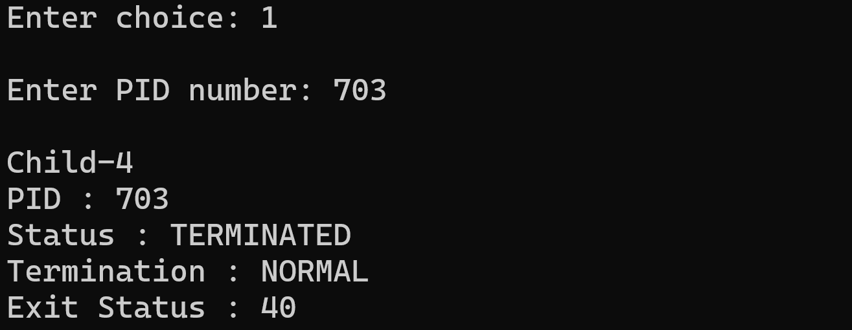

Screenshot 21: Query Child-5 using its actual PID — normal termination and exit status.
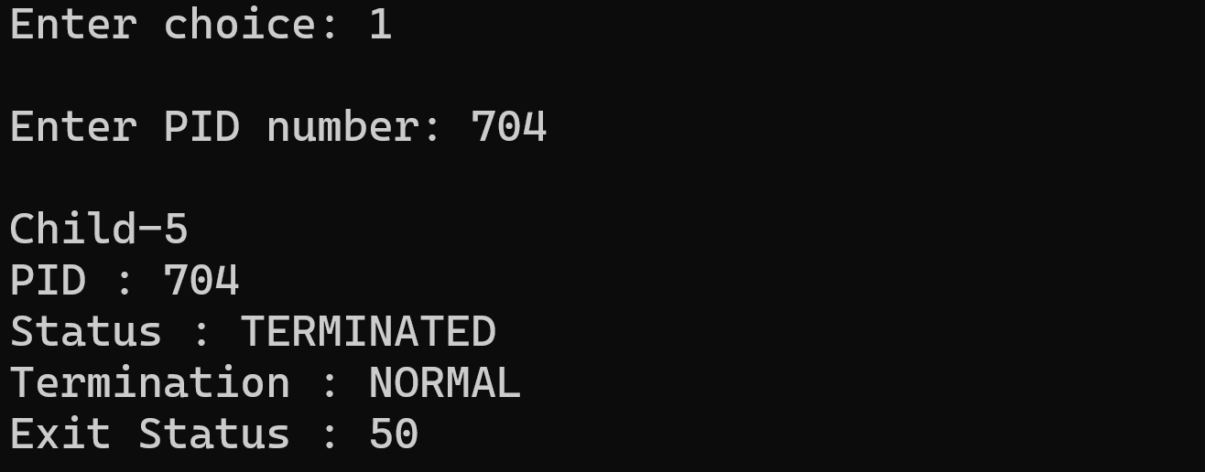

13. TERMINATION REPORT
Option 4 displays the final termination information for every child process.
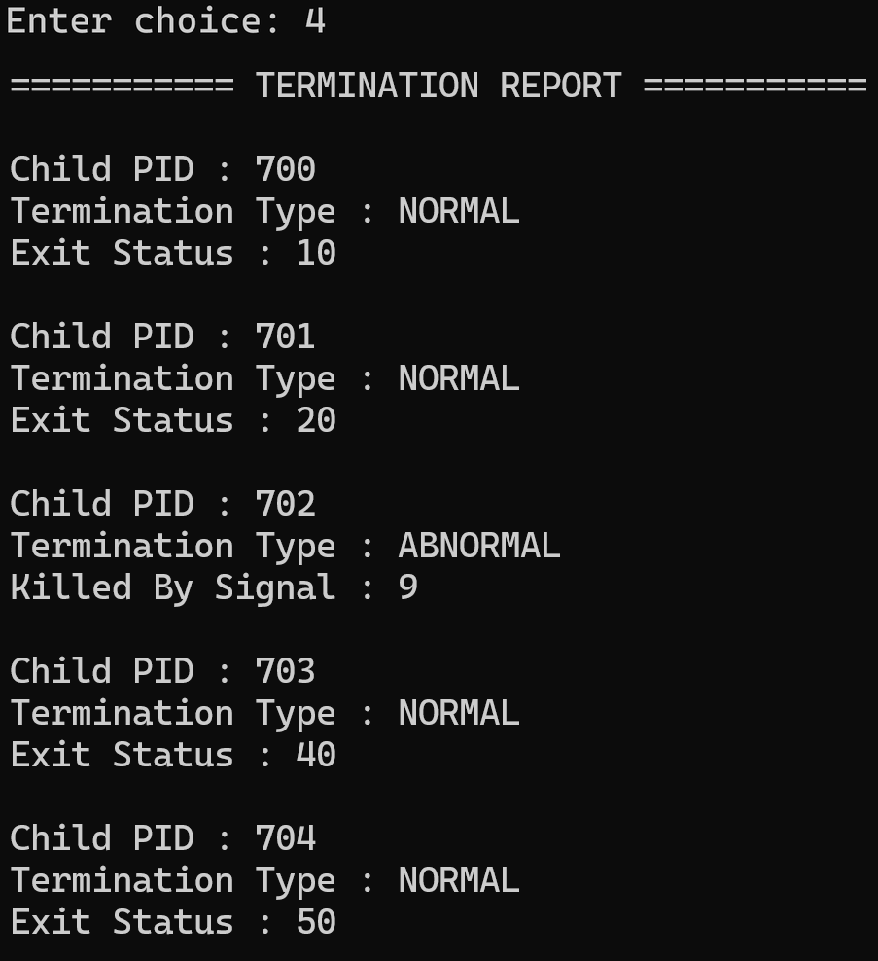
Screenshot 22: Complete termination report for all five child processes.

14. PROGRAM EXIT AND ZOMBIE PREVENTION
The menu remains available after all children terminate. The program exits only when option 5 is selected. Child processes are collected using waitpid() and the final wait() call.
Screenshot 23: Selecting option 5 and final message showing all children collected and no zombie processes.
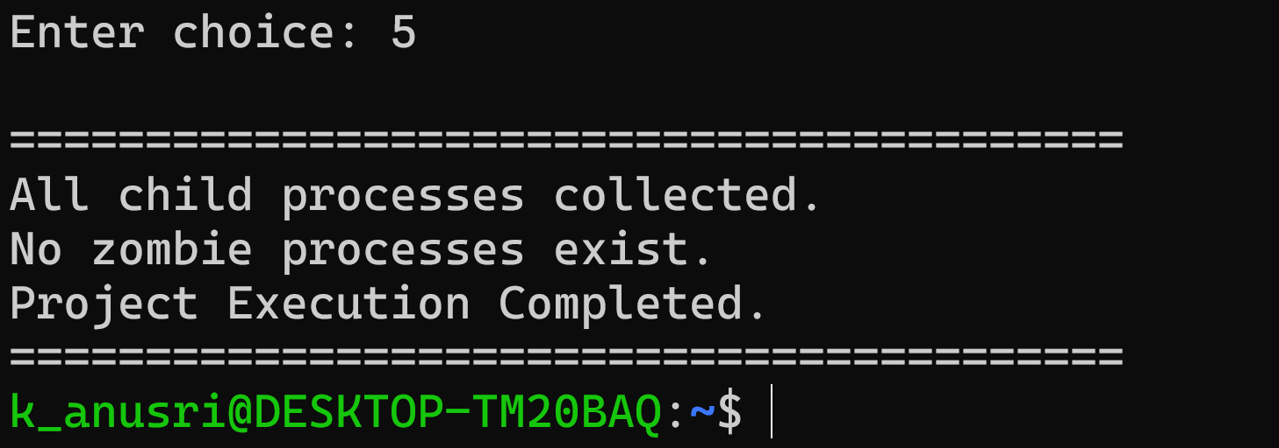

15. VERIFIED TEST RESULT
Child | PID (sample run) | Status | Termination | Result
Child-1 | 700 | TERMINATED | NORMAL | Exit 10
Child-2 | 701 | TERMINATED | NORMAL | Exit 20
Child-3 | 702 | TERMINATED | ABNORMAL | Signal 9
Child-4 | 703 | TERMINATED | NORMAL | Exit 40
Child-5 | 704 | TERMINATED | NORMAL | Exit 50
Note: PIDs are assigned by Linux and normally change when the program is run again.

16. EXECUTION FLOW
- Start the parent process.
- Select 3–100 child processes.
- Allocate shared process information using mmap().
- Create children using fork().
- Assign and display child PIDs.
- Move children through STARTED and PROCESSING states.
- Terminate Child-3 using SIGKILL for abnormal termination demonstration.
- Use waitpid() to collect terminated children and record status.
- Use the menu to query PIDs, show all statuses, send SIGKILL, or display the termination report.
- Continue until option 5 is selected.
- Collect remaining children, release shared memory, and exit.

17. RESULT
The enhanced Process Termination Message System was successfully implemented and tested. The system supports a user-selected number of child processes from 3 to 100, maintains PID-based process information, detects normal and abnormal termination, provides an interactive monitoring menu, and prevents zombie processes through child collection.

18. CONCLUSION
This project demonstrates Linux process-management concepts using C system calls and status macros. The implementation provides practical understanding of process creation, process states, PID tracking, signal-based termination, synchronization, termination-status analysis, and zombie prevention. The menu-driven design allows the user to inspect processes after termination without restarting the program.

19. TEAM CONTRIBUTIONS
- 2520030432 – K ANUSRI: fork-based process creation, process-status integration, and overall program integration.
- 2520030440 – K ANSHU: normal process termination and exit-status handling.
- 2520030193 – K DHEERAJ: abnormal termination and signal handling.
- 2520030028 – B MOHITH: testing, output verification, documentation, and GitHub support.

20. TOOLS AND TECHNOLOGIES
- Ubuntu Linux
- C Programming Language
- GCC Compiler
- Nano / Text Editor
- Linux Terminal
- GDB – GNU Debugger (debugging tool when required)
- Git and GitHub

21. GITHUB
Project repository: https://github.com/kanusri-tmj/Jarvis-kernel_OSSP

22. FINAL VERIFICATION CHECKLIST
☐ User-selected child count from 3 to 100 tested.
☐ Child PIDs displayed correctly.
☐ Process states tracked.
☐ PID-based query verified for each child.
☐ All-process status table verified.
☐ Normal termination and exit status verified.
☐ SIGKILL abnormal termination verified.
☐ Complete termination report verified.
☐ Menu remained active after all children terminated.
☐ Option 5 exited the program cleanly.
☐ No zombie processes reported.

